SKYREME Auto Mechanic Workshop
Content Research and Sourcing
1. Organisation Overview
SKYREME Auto is a fictional independent auto mechanic workshop established in 2024. The business provides vehicle repairs, engine testing and routine vehicle servicing. The target audience is local vehicle owners and businesses that require reliable vehicle maintenance.
2. Website Content Research
Research was gathered to understand the types of services commonly offered by automotive workshops in South Africa. This research was used to help develop the Services, About Us, Enquiry and Contact pages of the SKYREME website.
3. Services Research
The SKYREME website includes services such as:
- Vehicle servicing
- Engine testing
- Brake inspection and repair
- General vehicle repairs
4. Target Audience Research
The website is aimed mainly at:
- Local car owners
- People needing vehicle repairs
- Customers looking for routine servicing
- Businesses with vehicles that require maintenance

5. Image Sourcing
The website uses workshop images to support the visual design and represent the services offered by SKYREME Auto.
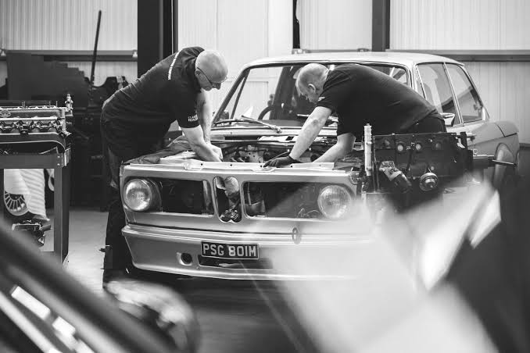
Figure 1: Mechanic working on vehicle. (Olmedo, 2021)
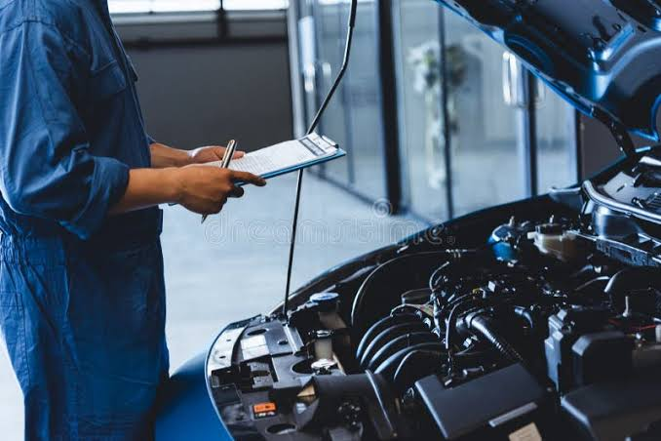
Figure 2: Vehicle receiving mechanical service. (Dreamstime, [s.a.])
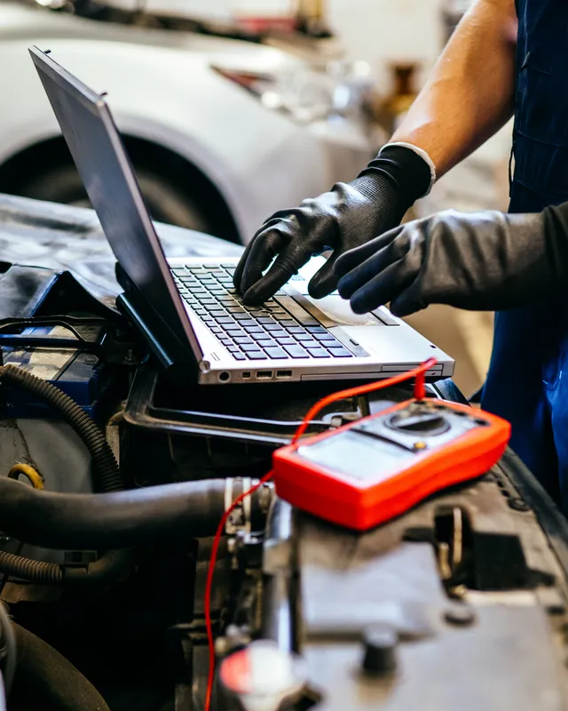
Figure 3: Engine diagnostics and testing. (Adobe Stock, 2020)
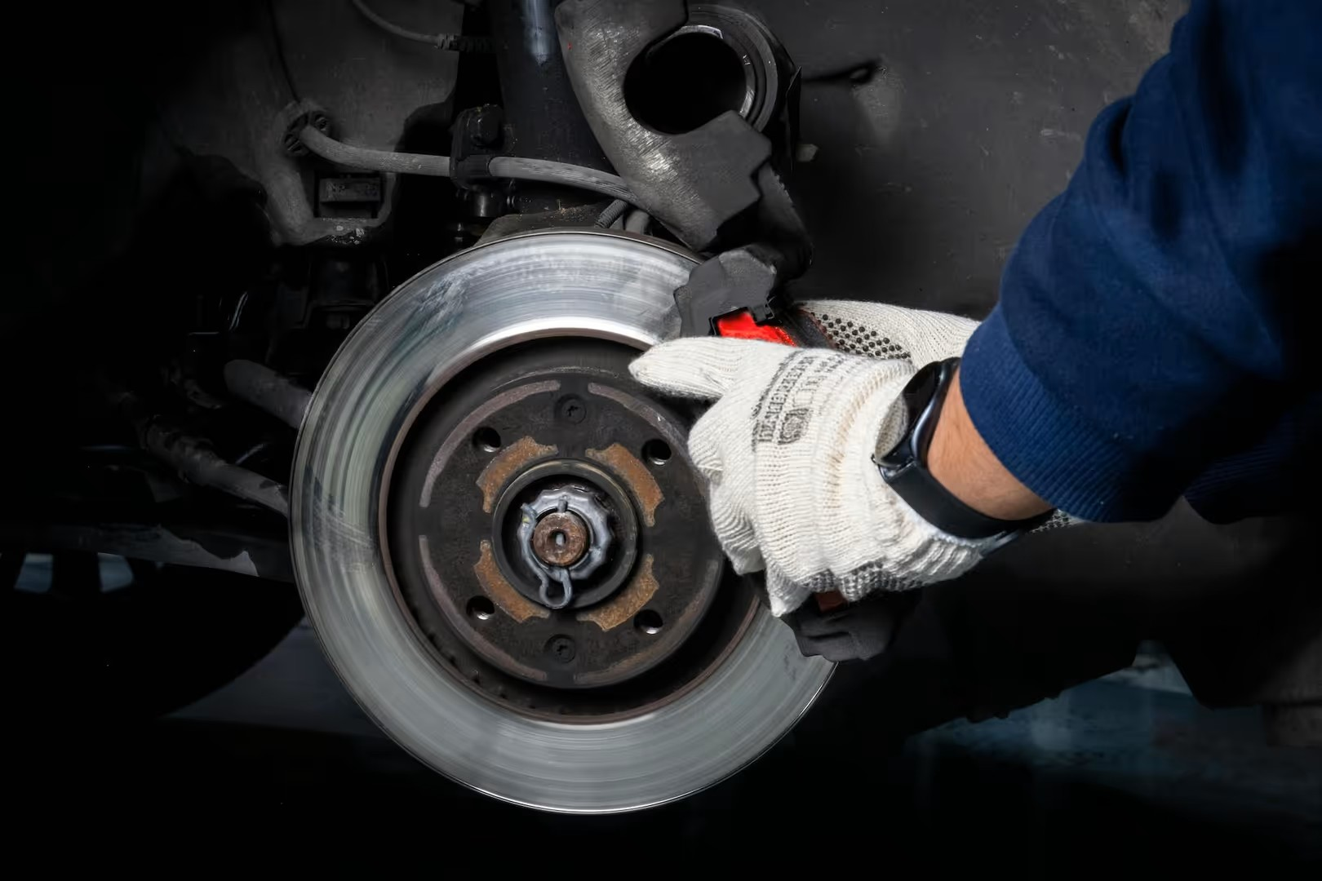
Figure 4: Brake inspection. (The Hero Motor Company,[ s.a.])
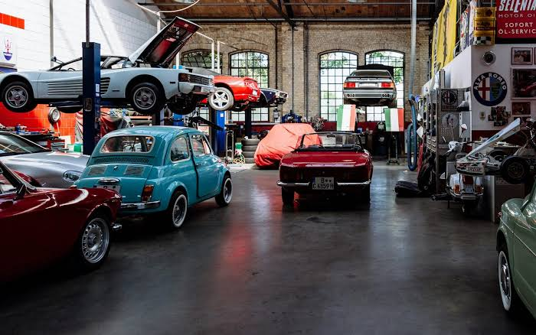
Figure 5: SKYREME Auto mechanic workshop. (Suprun, 2018)

Sitemap
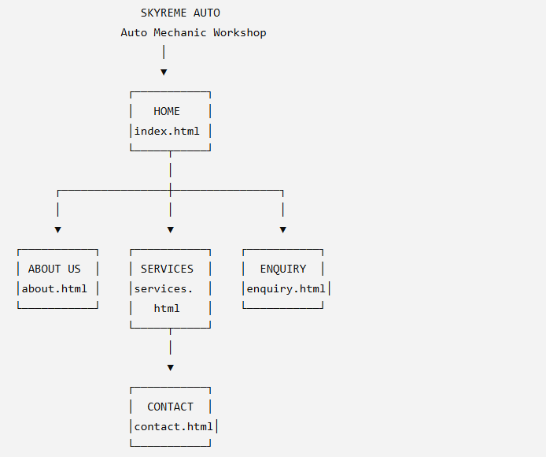

Sourcing
- Auto Repair in Royal Oak, [s.a.]. Vehicle Assessment Services. [image online] Available at: <https://www.firstcallauto.com/car-diagnostic-test-royal-oak-mi > [Accessed 12 August 2026].

- Bearverton INFINITI, 2025. 5 Signs Your Vehicle Needs A Brake Inspection. [image online] Available at: <https://www.beavertoninfiniti.com/5-signs-your-vehicle-needs-a-brake-inspection/ > [Accessed 12 August 2026].

- Dreamstime, [s.a.]. Car servicing. [image online] Available at: <https://www.dreamstime.com/mechanic-holding-clipboard-checking-inside-car-to-maintenance-vehicle-customer-claim-order-auto-repair-shop-garage-image169448280 > [Accessed 12 August 2026].

- Minnie, L., 2025. Car service costs in South Africa: What to expect. [online] Available at: <https://www.autotrader.co.za/cars/news-and-advice/car-ownership/car-service-costs-in-south-africa-what-to-expect/16304> [Accessed 25 July 2026].

- Minnie, L., 2024. How often should you service your car? [online] Available at: <https://www.autotrader.co.za/cars/news-and-advice/car-ownership/how-often-should-you-service-your-car/14269 >[Accessed 12 August 2026].

- The Hero Motor Company, [s.a.]. Our Workshop. [image online] Available at: < https://heromotorcompany.co.uk/workshop/ > [Accessed 12 August 2026].

- SpeedwayMedia, 2025. Building the Ultimate Car Workshop: What You Actually Need to Get It Right. [image online] Available at:< https://speedwaymedia.com/2025/06/18/building-the-ultimate-car-workshop-what-you-actually-need-to-get-it-right/ > [Accessed 12 August 2026].

- Writer, S., 2018. Servicing your car to become much cheaper in South Africa. [online] Available at:< https://mybroadband.co.za/news/motoring/280905-servicing-your-car-to-become-much-cheaper-in-south-africa.html> [Accessed 25 July 2026].

